**ALY6080 Integrated Experiential Learning**

**Submitted by** – Tanishq Bakliwal

**Submitted to** – Prof. Valerie Atherley

**Assignment** – Module 10 (Individual Project Proposal Draft-2)

**Submission date** – 03/17/2024

**CRN Number** – 20487

**Academic Term** – Winter 2024

**Using Data Analytics to Unlock Operational Excellence in Cabinet Manufacturing**

**A. Introduction**

Bow Wood Cabinets' unwavering commitment to precision and originality has allowed company to stand out in the competitive cabinet manufacturing industry. Through innovative use of data analytics, the company seeks to fortify its market position, strategically get around industry roadblocks, and enhance operational effectiveness—all of which will bolster its long-term competitiveness.

**B. Industry Challenges and Bow Wood Cabinets' Success**

The industry that manufactures cabinets confronts particular obstacles. Rapid shifts in design trends have the potential to make current designs outdated. Manufacturing processes are continually evolving due to technological developments. Furthermore, market differentiation requires a deep comprehension of consumer preferences across several market categories.   
  
Bow Wood Cabinets has thrived despite these obstacles because of its flexibility. It is admirable that they were able to change course and adapt to these shifting market conditions. But adaptability alone isn't enough due to the industry's complexity. In order to stay ahead of the competition over time, Bow Wood Cabinets has to use a data-driven strategy.

**C. Statement of Purpose**

Increasing inventory levels, streamlining logistics, and forging strategic alliances with suppliers are the main goals of this initiative. Using contemporary data analytics methods could enable this. Bow Wood Cabinets will perform a thorough analysis of historical and current data in order to identify patterns, identify critical success factors, and glean insightful information. In order to achieve operational excellence and eliminate operational bottlenecks, which will eventually support Bow Wood Cabinets' ongoing development and profitability, a data-driven strategy is vital.

**D. Review of Literature**

**Article 1: Title: Supply Chain Visibility in Real Time**one, Q. (2024, January 22). *What is real-time supply chain visibility?*. QIMAone. <https://www.qimaone.com/resource-hub/real-time-visibility-series>

Real-time supply chain visibility depends on having access to the most recent information on the whereabouts and conditions of commodities as they travel through the supply chain, as the article makes clear. The capacity to quickly resolve issues, enhance the product's quality, and raise client happiness through precise delivery estimates and product tracking are a few of the most noteworthy benefits. The report does, however, note several difficulties, including the complexity of supply chain mapping, the requirement for technological investments, and the requirement for staff training in data analysis and new tool usage.

Businesses who adopt real-time visibility report a significant boost in customer happiness and supply chain efficiency, based on the information given in the article. Interestingly, businesses who have used real-time visibility have successfully reduced their transportation costs by 10% on average. According to the study, real-time intelligence reduces costs and addresses business issues by streamlining transportation routes, grouping shipments, negotiating better rates with logistics providers, and encouraging more collaboration with suppliers and logistical partners. The report concludes by making a strong case for businesses to use real-time supply chain analytics and highlighting the advantages of do so, including increased customer satisfaction, reduced expenses, and increased operational effectiveness.

**Article 2: Title: Formulating a Successful Logistics**Anvyl. (2023, October 26). How To Develop a Winning Logistics Strategy. Retrieved from <https://anvyl.com/blog/logistics-strategy/>

The article emphasizes how important logistics are to a business's success and defines a logistics strategy as a thorough plan with the goal of supply chain optimization. It highlights the importance of long-term goals, which ought to provide advantages like increased output and client pleasure. The essay offers twenty-five quick fixes for improving logistics strategy that are all focused on cooperation, sustainability, anticipating risks, and using technology.

The article's main focus is on effective logistics planning to satisfy customer demand while maintaining inventory levels. It tackles the problem of increasing inventory while preventing surplus stock by focusing on important concepts including supply chain visibility, optimizing inventory management, and comprehending long-term objectives. Strategies such as automated systems and integrated shipping carriers are emphasized as ways to increase efficient inventory control and boost customer satisfaction. The essay emphasizes how important it is to put in place a careful logistics plan in order to strike a delicate balance between satisfying customer demand and efficient inventory control.

**Article 3: Title: Optimal Strategies for Reducing Supply Chain Costs**Pallet Market Inc. (2023, February). Best supply chain cost reduction strategies. Retrieved from <https://www.palletmarketinc.com/blog/best-supply-chain-cost-reduction-strategies>

Using strategic supply chain cost-cutting methods is necessary to effectively manage the rising costs in today's business climate in order to protect and improve profitability. A thorough approach includes careful budget planning, close examination of labor and staff costs, and investigation of automation as a means of enhancing supply chain delivery and storage efficiency. "Supply chain network design" places a strong emphasis on integrating technology to lower mistake rates.

Reducing costs overall is facilitated by outsourcing to third-party logistics firms (3PLs) and building enduring partnerships with dependable suppliers. Increased supply chain efficiency may be attained by investing in appropriate pallets and combining skills and digital technology in a synergistic way. Cutting-edge technology, a competent quality control staff, and a focus on customer service all work to reduce returns and increase client loyalty. Adopting sustainable methods, like solar panel installation, lowers insurance costs, improves worker safety, and is consistent with eco-friendly ideals. These strategies successfully protect businesses from cost limitations, guaranteeing a strong and effective supply chain that increases profitability.

**E. Project Scope**

The endeavor's pillars are data interchange and advanced analytics. Our team will use state-of-the-art analytical tools such as machine learning algorithms and statistical software (like R and Python) to extract useful insights from the Bow Wood Cabinets data.   
  
An essential component of this endeavor is predictive modeling. These models will be used to determine the main variables influencing demand, sales, and operational effectiveness. Additionally, these models will offer precise forecasts of future sales and demand, enabling Bow Wood Cabinets to schedule its manufacturing, manage its inventory, and allocate its resources in advance.

**F. Analysis of Competitors**

Acquiring additional knowledge about rivals is necessary to keep a competitive edge. Bow Wood Cabinets may get important insights by closely examining the tactics, advantages, and disadvantages of rival data analytics companies. Through the examination of rival marketing campaigns, product offerings, and pricing strategies, we may be able to pinpoint areas in which Bow Wood Cabinets may modify its strategy in order to set itself apart from the competition. This will allow the business to make little adjustments and keep its leading position in the industry.

**G. Background Research and Literature**

This effort's emphasis on using data to inform choices is in line with contemporary supply chain procedures. Bow Wood Cabinets hopes to strengthen its operational and financial resilience in a rapidly evolving industry by carefully using data analytics.   
  
An increasing amount of scholarly literature emphasizes how data analytics may revolutionize the industrial sector. According to studies, businesses that utilize data to guide their decisions see advances in productivity, cost savings, and customer happiness. This initiative aims to raise Bow Wood Cabinets to the top of the industry using these insights.

**H. Method of Design and Data Collection**

R, Python, Tableau, and Spark are some of the data analytics technologies I'll utilize for thorough data exploration, statistical testing, and predictive analysis. These techniques will enable Bow Wood Cabinets to:

* **Visualize trends:** Tableau will be crucial in creating interactive dashboards that provide graphical representations of supplier performance, sales, and inventory patterns. These dashboards will provide a clear and concise breakdown of the most significant metrics, enabling stakeholders to identify trends and make informed decisions.
* **Gain knowledge:** We may investigate the relationships between different variables by using R or Python for statistical testing. For example, we can examine the impact of marketing campaigns or raw material prices on sales figures. This deeper knowledge influenced the strategic decision-making of several divisions.
* **Make informed decisions:** Python or R machine learning techniques will be used to develop predictive models. These algorithms will optimize inventory levels, forecast future demand, and identify any manufacturing bottlenecks. By being proactive and preparing ahead, Bow Wood Cabinets can minimize disruptions and maintain seamless operations.
* **Privacy and Data Security:** Maintaining privacy and data security is essential. In order to safeguard the personal data of Bow Wood Cabinets, we will use robust security protocols and adhere to all relevant data privacy legislation.
* **Data Preparation and Cleaning:** Real-world data frequently contains missing values and inconsistencies. Our staff will use data cleaning procedures to ensure the data is correct and complete before beginning any analysis. This might mean finding and correcting errors, adding missing numbers, and standardizing data formats.
* **Data Integration:** Information at Bow Wood Cabinets may be spread throughout many departments. We'll devise a strategy to integrate data from many sources, such as sales records, CRM systems, and industrial databases. by encouraging a deeper comprehension of the business and facilitating more in-depth study.

**I. Implementation Methodology and Strategies**

The strategies and methods of implementation for data analytics tools need to mesh well. Here's a rundown of two crucial instruments:

* **Interactive Dashboards:** Through engagement with interactive dashboards, stakeholders may discover real-time information regarding key performance indicators (KPIs) from several departments. These dashboards will have an attractive look and make it easy to access crucial information.
* **Predictive models:** These models will provide statistical rigor to data-driven decision-making. Ongoing monitoring and updating will guarantee the models' correctness and effectiveness in predicting future changes.

A thorough understanding of Bow Wood Cabinets' operations is produced by combining quantitative data analysis—obtained via statistical testing and prediction models—with qualitative insights—obtained through stakeholder interaction. This synergistic approach will improve decision-making and provide a deeper understanding of the company.   
  
The purpose of this revised part is to give a more thorough description of the methods used for data gathering, data analytics, and implementation strategies.

**J. Types of Data and Analysis for Bow Wood Cabinets**

Bow Wood Cabinets plans to utilize an assortment of data points in order to have a thorough understanding and enhance its operations. The following is a summary of important data categories and the related analysis methods:

1. **Past Sales Information**

**Data Type:** Transactional data with sales figures, revenue received, and product specifics (size, material, style, etc.) including past sales information.

**Evaluation:**

* **Statistical Analysis:** Conduct hypothesis testing to look for trends in sales performance over a range of product categories, regions, or price points. One way to compare the sales of newly announced product lines with those of existing ones is through the use of t-tests.
* **Regression Models:** Develop regression models to investigate how external factors, like as marketing initiatives, seasonality, and general economic patterns, affect sales. This will allow Bow Wood Cabinets to plan its manufacturing schedule and marketing strategies more effectively during peak periods.

1. **Supplier Performance Metrics**

**Data Type:** Examples of metrics include price plans, contract compliance (such as minimum order quantities), percentages of on-time delivery, and product quality (defect rates).   
  
**Evaluation:**

* **Statistical Analysis:** Apply statistical tests, such as chi-square testing, to evaluate the performance of many providers across various metrics. This will help identify the most affordable and trustworthy services.
* **Correlation Analysis:** Correlation analysis is a useful tool for identifying relationships between supplier performance data. For example, is there a connection between the product's quality and its timely delivery? Establishing such links can help guide supplier management strategies.

1. **Logistics and Transportation Data**

**Data Type:** Examples of data types include delivery schedules, shipment routes, fuel and shipping prices, and efficiency measures like delivery times per mile.   
  
**Evaluation:**

* **Geographic Data Analysis:** Use geographic information systems (GIS) to look at transportation routes and identify areas for improvement. This may mean finding shorter routes, avoiding crowded locations, or bundling freight in order to save transportation costs.
* **Predictive Techniques:** Based on historical performance and current traffic conditions, forecasting algorithms may be used to identify the optimal times to transmit things. This will shorten delivery delays and expedite client fulfillment.

**K. Benefits of Data Analytics for Bow Wood Cabinets**

Bow Wood Cabinets may be able to foresee the following benefits from using a data-driven strategy:

* **Improved Operational Efficiency:** Data analytics may improve resource allocation, cut down on waste, and streamline processes. This leads to reduced costs, faster turnaround times, and overall increased efficiency.
* **Improved Decision-Making:** Enhanced Decision-Making Data-driven insights may be used by all departments to inform their strategic decision-making. Data will paint a clear picture of what needs to be changed and what is already functioning in everything from inventory management to marketing initiatives.
* **Better Supplier Relationships:** By analyzing supplier performance data, Bow Wood Cabinets may identify areas for improvement and negotiate better terms with present suppliers. Data may also be useful when selecting new, reliable providers.
* **Enhanced Customer Satisfaction:** By optimizing inventory management and logistics, Bow Wood Cabinets can ensure on-time delivery and lower stockouts. As a consequence, there is an increase in client retention and improved consumer satisfaction.
* **Proactive Risk Management:** Predictive algorithms are able to anticipate potential roadblocks such as unexpected demand surges or shortages of specific supplies. Bow Wood Cabinets is able to proactively lower risks and maintain company continuity as a consequence.
* **Gaining a Competitive Advantage:** By employing data analytics to improve customer satisfaction and optimize operations, Bow Wood Cabinets can differentiate itself from competitors and hold onto its market position.

**L. Conclusion**

By employing the recommended data analytics techniques and leveraging a variety of data types, Bow Wood Cabinets will be able to gain a thorough understanding of its operations, identify areas for improvement, and make well-informed decisions that maximize all facets of the business. Statistical tests and models will help with trend detection and the comprehension of underlying causes, while forecasting models will assist with proactive planning and risk reduction. Bow Wood Cabinets will be able to overcome business challenges, maximize efficiency in each division, and enjoy sustained success in the competitive cabinet manufacturing market with this comprehensive plan.

**Important lessons learned:**

* Thanks to data analytics, Bow Wood Cabinets can now make well-informed decisions based on empirical facts rather of simply gut emotion.
* Analyzing several data elements, including supplier performance metrics, sales data, and logistics data, can help us understand operations better.
* Putting this concept into practice will provide you a competitive edge, improved decision-making, stronger relationships with suppliers, more customer happiness, and proactive risk management.

**Request for Action:**

By investing in data analytics, Bow Wood Cabinets may position itself for long-term success in the competitive cabinet manufacturing industry. This proposal offers a thorough plan for leveraging data to greatly improve operations. We implore Bow Wood Cabinets to move on with this project in order to fully fulfill its potential.

**M. Visuals:-**

Following are my visuals on the basis of my topic:-

1. **Statement of Purpose: Simplifying logistics, managing inventory, and strategic supplier engagement through data analytics.**

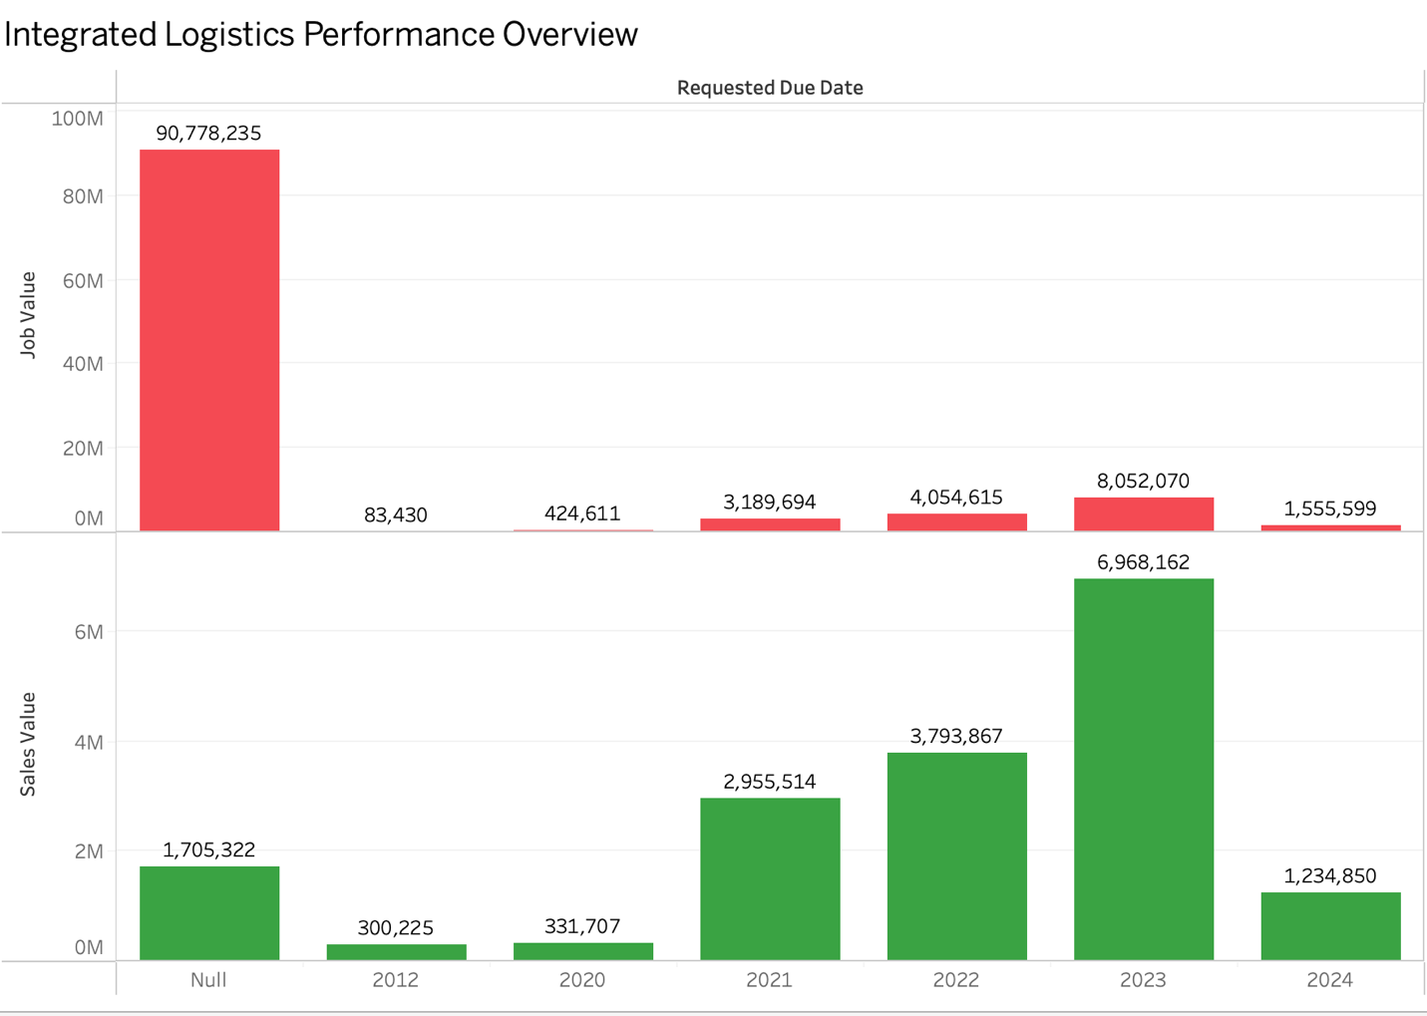

In the data visualization, the primary focus will be on simplifying logistics, inventory management, and enhancing strategic supplier engagement through the integration of data analytics. The visualization will encompass a comprehensive flowchart or process diagram illustrating the streamlined logistics processes, emphasizing the integration of data analytics at key junctures. Additionally, the visual representation will include graphs showcasing the evolution of optimized inventory levels over time, offering insights into trends and patterns. Furthermore, collaborative aspects of strategic supplier engagement will be highlighted through visuals, emphasizing the dynamic and interactive nature of data-driven decision-making in fostering effective partnerships with suppliers. The goal is to provide a clear and concise visual narrative that conveys the efficiency gains, inventory optimization, and collaborative advantages achieved through the strategic application of data analytics in logistics and supplier engagement.

1. **Analytics in Literature: Real-Time Supply Chain Visibility**

In this real-time supply chain visualization, the focus is on creating an interactive dashboard that provides insights into key metrics, monitoring tools, and analytics platforms. The dashboard will dynamically display critical information such as sales values over time, project statuses using color-coded indicators, and relevant project details like client names and tender close dates. The design will incorporate time-based filters for flexibility, allowing users to examine data trends on a daily, weekly, or monthly basis. Additionally, key performance indicators (KPIs) or gauges will showcase important metrics, enabling stakeholders to quickly assess the overall health of the supply chain. The real-time nature of the dashboard, supported by continuous data updates, aims to demonstrate the impact of timely visibility on decision-making and responsiveness in the supply chain, enhancing strategic decision-making processes.

1. **Reducing Supply Chain Costs: Implementing cost-cutting methods using data analytics**

In the data visualization aimed at reducing supply chain costs through data analytics, the focus will be on showcasing the impact of specific cost-saving initiatives. The process involves identifying and defining key metrics reflecting supply chain costs, conducting a time-series analysis to observe trends, and creating comparative charts or graphs. The visualizations will highlight the before-and-after scenarios, employing elements like bar charts, line charts, and pie charts to effectively illustrate cost reductions. Interactive dashboards with filters and drill-down capabilities will enable stakeholders to explore specific cost categories or time periods. Visual cues, annotations, and breakdowns of cost components will be employed to emphasize areas of significant improvement, providing insights into how data analytics optimizes transportation costs, reduces excess inventory, and improves procurement efficiency. Key performance indicators (KPIs) will be displayed to quantify the success of cost-saving initiatives, accompanied by a narrative that explains the methodology, key findings, and lessons learned in the journey to reduce supply chain costs.

**M. References:-**

* one, Q. (2024, January 22). *What is real-time supply chain visibility?*. QIMAone. <https://www.qimaone.com/resource-hub/real-time-visibility-series>
* Anvyl. (2023, October 26). How To Develop a Winning Logistics Strategy. Retrieved from <https://anvyl.com/blog/logistics-strategy/>
* Pallet Market Inc. (2023, February). Best supply chain cost reduction strategies. Retrieved from <https://www.palletmarketinc.com/blog/best-supply-chain-cost-reduction-strategies>
* Katana MRP. (2023, March 11). Manufacturing Analytics: The Metrics You Need. <https://katanamrp.com/blog/manufacturing-analytics/>
* Harvard Business Review. (2020, February 21). The data-driven mindset. [Harvard Business Review Insight Center]. Retrieved from <https://hbr.org/insight-center/the-data-driven-mindset>
* 1308031437975826437, kili. (2024, February 4). *How to clean dataset using python, and why you need to do so*. <https://kili-technology.com/data-labeling/machine-learning/cleaning-your-dataset-in-python-an-introduction>
* Southern Oregon University [Online]. (2023, October 26). GIS Mapping in Business [Website]. Retrieved from <https://online.sou.edu/degrees/business/mba/information-analysis-and-decision-making/gis-mapping-in-business/>